**Liquid-Phase Laser Synthesis of Magnetic Nanoparticles from Thin Co Films**

**I. Dzhun1, V. Nesterov2,3, Ya. Mineev2, D. Shuleiko2, D. Presnov1,2, E. Konstantinova2, N. Chechenin1,2 and S. Zabotnov2**

*1- Lomonosov Moscow State University, Skobeltsyn Institute of Nuclear Physics, 1/2 Leninskie Gory, Moscow, 119991, Russia*

*2- Lomonosov Moscow State University, Faculty of Physics, 1/2 Leninskie Gory, Moscow, 119991, Russia*

*3- Moscow Institute of Physics and Technology, 9 Institutsky lane, Dolgoprudny, 141701, Russia*

*E-mail: nesterovvy@my.msu.ru*

Today, magnetic nanoparticles (MNPs) are widely used in biomedicine, catalysis, data storage, environmental remediation and sensorics. Cobalt oxides are of interest due to their relatively high magnetic moment, spinel structure, unique properties and low cost [1]. Pulsed laser ablation in liquid (PLAL) is a universal, efficient and “green” method for producing chemically pure cobalt oxide MNPs in a one-step process, without the use of chemical reagents. The advantages of the PLAL method are the ability to control the size and composition of MNPs by varying the laser radiation parameters and the choice of buffer liquid.

Using PLAL targets of thin films of varying thicknesses instead of a bulk target for MNPs production potentially adds an additional possibility to control MNPs sizes. In our work, we studied PLAL generation of colloidal MNPs in distilled water from thin (5–500 nm) Co films magnetron sputtered. These films were irradiated by a Nd:YAG laser EKSPLA PL 2143A (1064 nm, 34 ps).

The results of scanning electron microscopy showed that the obtained MNPs are predominantly spherical agglomerates, but there are also flakes and coagulants with different shapes, which is confirmed by the transmission electron microscopy data (Fig. 1a, b). The dependence of hydrodynamic size of MNPs obtained from dynamic light scattering data on the film thickness is non monotonic (Fig. 1c). The ablation threshold values and ablation types depend on the thickness of the Co film. The ablation threshold for thicknesses of 5–35nm ranges from 0.6 to 1.5 mJ/mm2 and the ablation craters correspond to a phase explosion ablation. The ablation threshold for thicknesses of 35–500 nm lies in the range of 1.5–3 mJ/mm2 and in these cases spallative ablation occurs. The colloid size distributions obtained are characterized by the following standard deviations: ~40% for 500–50 nm films and ~20% for the thinner films [2]. These peculiarities are connected to changing the ablation mechanism near the skin layer depth that was estimated as 38 nm.

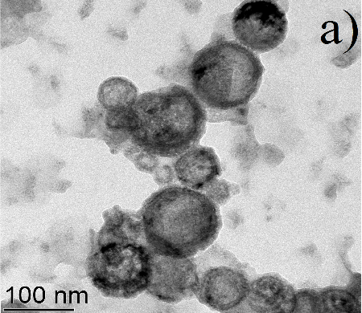 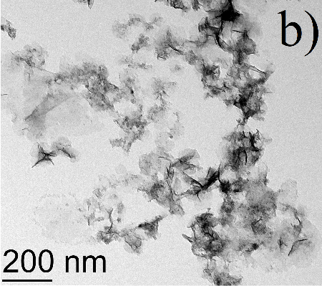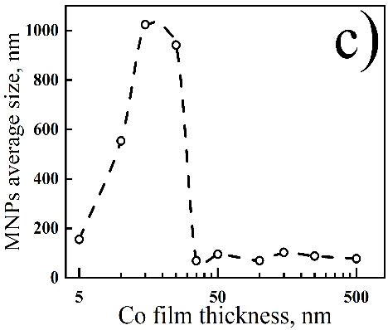

Fig. 1. Transmission electron microscopy images of MNPs obtained by laser ablation of Co films with thicknesses of 500 nm (a) and 15 nm (b) and the dependence of the average size of MNPs on the thickness of the Co film (c).

The produced colloids of MNPs demonstrated magnetic response. Ferromagnetic resonance spectra for MNPs are characterized by absorption peaks at a resonance field value of ~3700 Oe, which is close to the typical value for cobalt oxide C3O4 and indirectly indicates the presence of Co3O4 in the obtained MNPs. The Raman spectra of all formed MNPs nearly correspond to ones for the mineral guite (Co3O4).

This work was supported by the Basis foundation (project № 23-2-10-5-1)

[1] E.N. Ghaem, D. Dorranian, A.H. Sari, External magnetic field effects on the characteristics of cobalt nanoparticles prepared by pulsed laser ablation, Opt. Quant. Electron., 53, 36 (2021).

[2] I.O. Dzhun, V.Yu. Nesterov, D.V. Shuleiko, et.al., Magnetic Nanoparticles Produced by Pulsed Laser Ablation of Thin Cobalt Films in Water, Bull. RAS: Phys., 88, 540-548 (2024).