**Laser fragmentation of silicon microparticles in water by nano- and picosecond laser pulses**

V. Yu. Nesterov, D. V. Shuleiko, O.I. Sokolovskaya, A. V. Kolchin, D. E. Presnov, S. V. Zabotnov, L. A. Golovan

Lomonosov Moscow State University, Faculty of Physics, Moscow, Russia

e-mail: [n.slawa2011@yandex.ru](mailto:n.slawa2011@yandex.ru)

The method of laser fragmentation in liquids is an effective way to fabricate nanoparticles from larger particles [1]. For example, laser fragmentation of silicon microparticles (SiMPs) into nanoparticles allows to create structures for biophotonics [2], nonlinear optics, and plasmonics [3]. In the present work, we compare the structural properties of silicon nanoparticles (SiNPs) formed by the fragmentation technique with laser pulses of various durations.

The SiNPs were fabricated via laser fragmentation of mechanically grinded silicon as SiMPs (1–8 μm). The micropowder of various initial concentrations (0.5–12 mg/mL) in a water suspension was irradiated with 24 000 laser pulses using high-power radiation sources: a nanosecond Solar LS LQ629 laser (1064 nm, 12 ns, 200 mJ) or a picosecond EKSPLA PL2143A laser (1064 nm, 34 ps, 16 mJ).

An analysis of scanning electron microscopy (SEM) micrographs revealed that the fabricated SiNPs have a relatively smooth surface and a shape which is close to spherical (fig. 1a). Mean SiNP sizes nonmonotonically vary from 134 to 322 nm depending on the initial concentration of SiMPs in the suspension and the laser pulse duration (fig. 1b). This behavior may be explained by features of laser beam focusing inside the turbid suspension of silicon scatterers at their different concentrations.

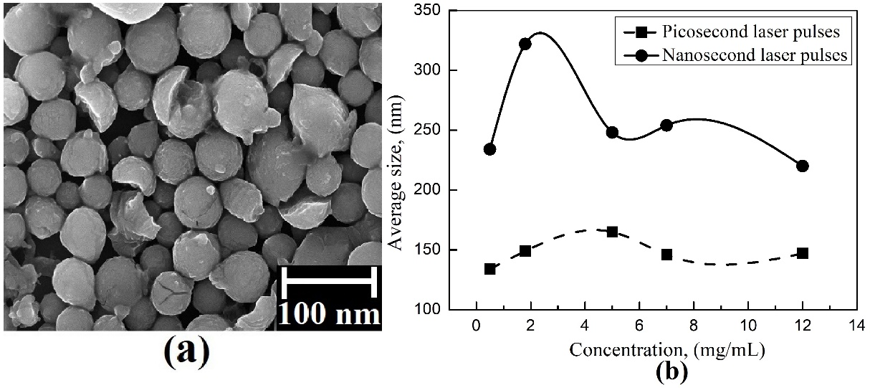

Figure 1: a) SEM-micrographs of SiNPs fragmented by picosecond pulses (the initial concentration is 12 mg/mL). b) Dependencies of SiNP mean sizes on initial concentrations.

Raman spectra of the fabricated SiNPs evidence their high crystallinity which promotes their effective light scattering and further use in the mentioned above applications.

REFERENCES:

[1] A. Al-Kattan, V.P. Nirwan et al., Int. J. Mol. Sci. 19, 1563 (2018).

[2] V.Yu. Nesterov, O.I. Sokolovskay et al., Quantum Electron. 52 (2), 160 (2022).

[3] S.O. Gurbatov, V. Puzikov et al. [Opt. Laser Technol.](https://istina.msu.ru/journals/95445/) 147, 107666 (2022).