**Balanced cross-section restoration in a complicated folded hinterland structure: Shilbilisaj profile, Talas Ridge, Caledonian Tien Shan**

*F.L. Yakovlev, K. Gaidzik, V.N. Voytenko, N.S. Frolova*

**Supporting information 2**

USING THE CONCEPT OF THE STRAIN ELLIPSOID AND THE FOLDED DOMAIN IN THE ANALYSIS OF EXPERIMENTS ON THE REPRODUCTION OF FOLDED STRUCTURES

Contents:

**Supporting information S2-1.** Folded domains in a deformed medium without folds

**Supporting information S2-2**. Folded domains and comparative analysis of natural and experimental structures

**Supporting information S2-1. Folded domains in a deformed medium without folds**

**The problem.** The method used to construct balanced structural cross-sections is primarily related to the concept of a strain ellipsoid and its transformations to a pre-folded state, and not to the morphology of folds, as it may seem at a first impression. The use of the interlimb angle (which brings the method closer to the definition of shortening by "measuring the length of the layer") is only one of the variants of the applied method. The principle of the strain ellipsoid is more general than the postulate of the layer length constancy. To illustrate this, we will use one of the first analyses of physical experiments on the reproduction of folding [Yakovlev, 1987].

**The nature of the physical experiment**. In the Laboratory of Tectonophysics and Geodynamics of Moscow State University, a series of experiments to reproduce large folding structures by advection or diapirism mechanisms were carried out on physical models made of colophony. To do this, rosin alloys of different colors were created. According to the modeling method, these layered models in the form of powder were heated until a homogeneous mass was formed. Inside such models, marks were applied by melting vertical zones using hot nichrome wires stretched with a horizontal pitch of 8 mm. Thus, a grid of vertical and horizontal lines was obtained in the initial model (Fig. 1, sign 2), which made it possible to control deformations at the final stage of the model. Then, during the physical experiment, the model was subjected to general heating with a noticeable vertical temperature gradient (when heated from below) for several hours. With a significant drop in the viscosity of the material during heating and with a sufficient vertical density gradient, convective structures were formed. In experimental structures of this type, there is no general horizontal shortening.

In one of the experiments, heating from the bottom occurred only for the right half of the model, which created a large horizontal gradient of the thermal field. In this model, a sharply asymmetric structure was formed with a deep narrow syncline in the left part of the model (Fig. 1, A). Since all the colored layers had the same viscosity, no small folds were formed during the structure development. In the author's interpretation [Goncharov, 1979; 1988] of the model, in the areas of shortening perpendicular to layering in the colophony medium, the folds are depicted by symbolic lines (Fig. 1, sign 3). In this regard, the entire mid-height part of the model shows a folded structure, in which transitions are observed from upright folds in the right part of the model to recumbent and plunging folds in the left part of the model.

**Measurements of structural parameters and the construction of a pre-folded section.** For the analysis, we used the model with 12 domains (Fig. 1, sign 1). The necessary parameters were determined for the domains, i.e., the axial surfaces dip angle (Ax), the envelope surface dip angle (En), the value of strain (K), and the lengths of the profile segments (their orientation was horizontal). Following the accepted rules, the fold axial surfaces (the long axes of the strain ellipses) were associated with the initially vertical lines of the control grid, the elongation of the medium along these lines was

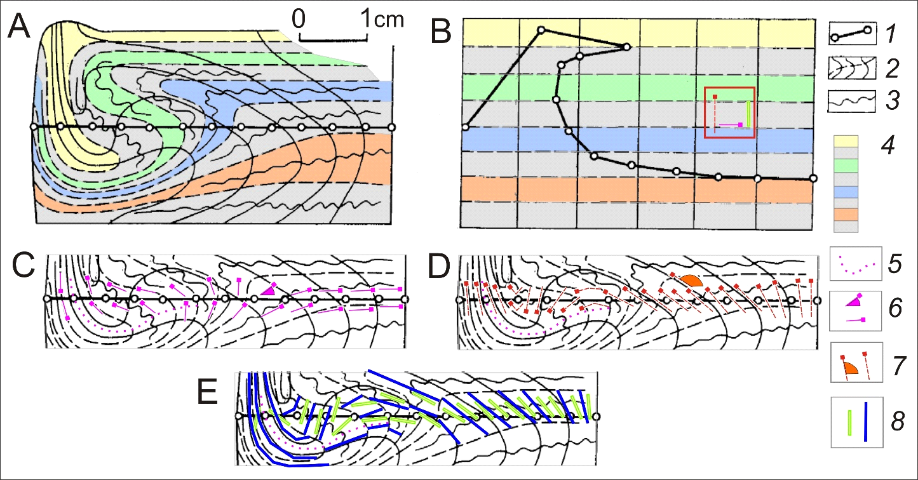

Fig. 1. A physical experiment on the reproduction of folded structures by the advection or diapirism mechanism and its analysis. A – The final form of the experimental model and the profile under study (according to [Goncharov, 1979; 1988], and [Yakovlev, 1987] with changes); B – The model in its original form with the applied profile in a pre-folded state (the same sources); the red square shows the positions of the axial surfaces, the fold envelope plain and the length of the long axis of the resulting strain ellipsoid; C, D, E – The positions of structural elements and their measurements in the middle part of the model: the envelope plane dip angle (C), the axial surfaces dip angle (D) and the lengths of segments (the long axis of the ellipsoid) used to calculate the strain value. 1 – A conditional profile consisting of 12 domains; 2 - A grid of vertical and horizontal planes controlling deformations; 3 – Symbolic representation of folds (M.Goncharov's drawing) in those parts of the structure in which folds could form; 4 – Color indication of different layers of the model (F.Yakovlev) to facilitate understanding of the structure; 5 – Position of the axial surface of a large syncline (on the hierarchic level of a "structural cell"); 6 – Position of the envelope plane and measurements of its inclination; 7 – Position of the axial surfaces of the alleged folds and measurements of their dip angle; 8 – Method of measuring the shortening values; the orientations of the long axes of the strain ellipse (blue lines) are shown, their lengths are compared with their initial lengths (green lines).

used to calculate the shortening value in the direction perpendicular to them (Fig. 1, C, D, E). For the convenience of measuring these parameters, contour maps of three main parameters were previously constructed over the model image. Since the first computer program for constructing a balanced section was compiled in 1995, calculations were carried out manually in the case under discussion (1987). The result of the analysis is shown in Figure 1B. The position of the domain boundaries (dots, Fig. 1, sign 1) in the original model (Fig. 1, B) can be controlled by the position of the grid nodes in Figure 1A. As can be noted, the technology of restoring the pre-folded profile allows us to obtain a reasonable result for this experiment, in which there are no structures with layering and, accordingly, there are no folds.

**Conclusions**

1. The provided material clearly shows the relationship between the structures of two hierarchical levels - folded domains (III level) and structural cell (IV level).

2. It also shows the possibilities of using the concept of a strain ellipsoid in the "folded domain" to restore the initial state of any deformed structures, even those in which there are no actual folds.

**Supporting information S2-2. Folded domains and comparative analysis of natural and experimental structures**

The same concept of a folded domain and a strain ellipsoid as a means of describing the structure deformation has been repeatedly used for generalized characterization of folding deformations under the influence of various mechanisms (Yakovlev, 2012b; 2015). The general idea is that measurements of the parameters Ax, En, Sh (K) in several domains (with their close values) form a relatively compact cloud of points in the 3D space of these parameters (Fig. 2). With the progress of a certain deformation process and the development of folds (with an increase in the amplitude/value of the process), such a cloud moves in this space along a certain trajectory. Such a trajectory is usually different from other tracks and is a kind of portrait of the mechanism. A detailed study of many experiments with different mechanisms was carried out, and a series of such trajectories were identified (Fig. 3, 4). This language for describing deformations allows us to compare with each other A) different stages of the same experiment (Fig. 4, A); B) different experiments with each other; C) different natural structures with each other; D) natural and experimental structures to diagnose the mechanisms of formation of natural structures. See ([Yakovlev, 2015], p. 332) for more details.

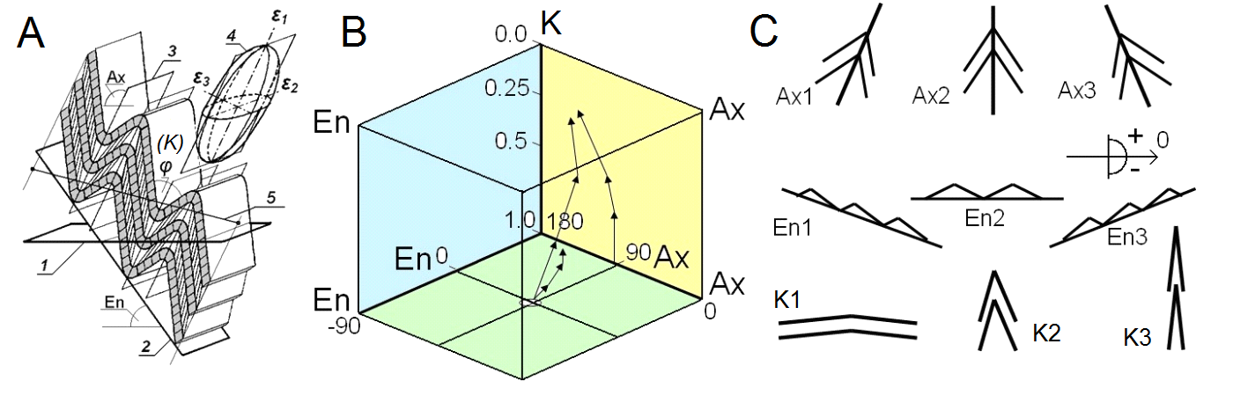

Fig. 2. Measurements of structural parameters (A) in the domain and its visualization in three-dimensional space (B), reflecting the process of structure development (after [Yakovlev, 2015], with changes). The variants of structural parameters (C).

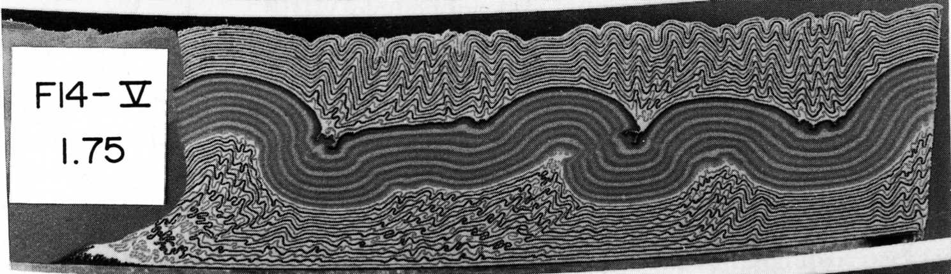

Fig. 3. Photo of a physical experiment (after [Dixon, Tirrul, 1991], with changes, [Yakovlev, 2015]) using a centrifuge, stage 3 of the F-14 series.

|  |  |
| --- | --- |
| A | B |

Fig. 4. Cumulative configurations of point areas showing two processes that were active in experiment F14 ([Yakovlev, 2015], with changes): horizontal (lateral) shortening (upper part of the structure with small folds), shortening with horizontal shearing in the lower part of the structure (A). The positions of the "front" (conditional signs) of the two processes and their trends (arrows and names of "mechanisms") are also shown for the same areas of points (outlined areas, as in "A") on the same diagram (B).

**Additional reference**

Dixon J.M., Tirrul R. (1991). Centrifuge modelling of fold-thrust structures in a tripartite stratigraphic succession. *Journal of Structural Geology*. v. 13. N 1. P. 3-20.

Goncharov, M.A. (1979). *Density inversion in the Earth's crust and folding.* Moscow: Nedra, 246 p. (in Russian)

Goncharov, M.A. (1988). *Mechanism of geosynclinal folding.* Moscow: Nedra, 264 p. (in Russian) <https://www.geokniga.org/bookfiles/geokniga-mehanizm-geosinklinalnogo-skladkoobrazovaniya.pdf>

Yakovlev, F.L., (1987). A study of the kinematic of linear folding (on the example of the South-Eastern Caucasus). *Geotectonics*, 21(4), 316–329. <http://yak.ifz.ru/pdf-lib-yak/yak-pap87-GEOTECT.pdf>

Yakovlev, F.L. (2015). *Multirank strain analysis of linear folding on the example of the Alpine Greater Caucasus.* Doctoral (of science) thesis. Moscow: IPE RAS. Unpubl. Manuscript. 472 p. (in Russian) <http://yak.ifz.ru/pdf-lib-yak/Yakovlev-doct_diss_2015-russ-full.pdf>