**Two methods of improving dopant contrast for structures under thin surface layers in scanning electron microscope**

E. Rau1, A. Tatarintsev1, 2, S. Kupreenko1, V. Karaulov3, S. Kolybin3

*1. Moscow State University, Moscow, Russia, E-mail:* [*rau@phys.msu.ru*](mailto:rau@phys.msu.ru)

*2. Institute of Physics and Technology of RAS, Moscow, Russia*

*3. JSC “NPO Sernia”, Moscow, Russia*

The development of modern nanotechnology requires of adequate accompanying diagnostic parameters and physical properties of submicron device structures. High-local methods of scanning electron microscopy are becoming more popular for this purpose. Methods of measuring the degree of doping and the spatial distribution of implanted impurities in semiconductor crystals are great of interest [1-3]. It is necessary to determine the type and concentration of impurities in the range of 1016-1020 cm-3 with a spatial resolution of nanometers to tens of nanometers.

Studied structures usually are covered with thin dielectric coatings or surface contamination layers. All of these factors decrease already weak contrast. Dopant mapping of such structures and explanation of contrast mechanisms are main problems of this work.

Task of dopant visualization can be solved by two methods. The first is based on detection of energetically filtered secondary electrons by toroidal electron spectrometer [1]. The second one is based on scanning mirror electron microscopy [4].

Images of test sample, which is a n-type silicon wafer with locally doped regions with p-type impurity (impurity concentration is 1018 cm-3), are depicted on Fig. 1. Energy filtration of secondary electrons increases dopant contrast to values of about 40 % (Fig. 1a), what is the record in scanning electron microscopy. But sample covered with oxide film (20 nm of SiO2) demonstrate significantly poor contrast (Fig. 1b). We will discuss this artifact in our report.

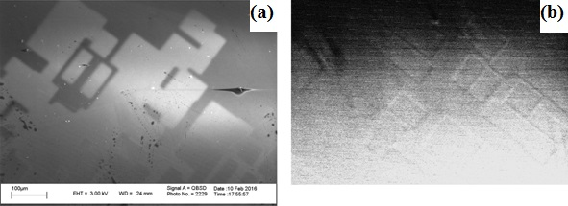

Fig. 1 Images of test sample (a) and sample covered with oxide film (b)

This work was funded thanks to the support of RFBR (grant 15-02-01557)

1. M. El-Gomati, F. Zaggout, H. Jayacody, S. Tear, K. Wilson. “Why it is possible to detect doped regions of semiconductors in low voltage SEM: a review and update”. Surf. Interface Anal., **37**, pp. 901-911, 2005

2. C. Rodenburg, M.A.E. Jepson, E.G.T. Bosch, M. Dapor. “Energy selective scanning electron microscopy to reduce the effect of contamination layers on scanning electron microscope dopant mapping”. Ultramicroscopy, **110**, pp. 1185-1191, 2010

3. A.V. Gostev, N.A. Orlikovskii, E.I.Rau, A.A. Trubitsyn.“Updating of the toroidal electron spectrometer intended for a scanning electron microscope”. Technical Physics, **58**, 3, pp. 447-454, 2013.

4. G.V. Spivak, V.P. Ivannikov, A.E. Luk’yanov, E.I. Rau. “Development of scanning mirror electron microscopy for quantitative evaluation of electric microfields”. J. Microsc. Spectrosc. Electron., **3**, pp. 89-100, 1978